**sales trends and customer purchasing behaviour – (2011 to 2016)**

**Introduction**

this data demonstrates 6 country (USA, Australia, Canda, France, Germany, UK) and there states we Analyzed through their product category and subcategory also, we have analysed profit, revenue by year and we have done trend charts also.

**Data insight & charts**

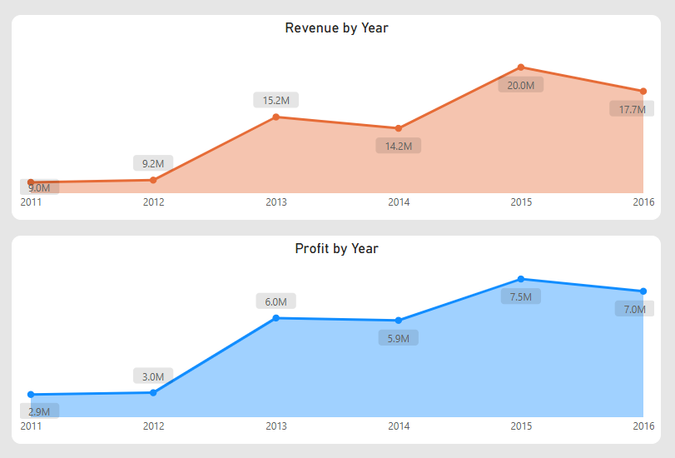85 million revenues have been generated & 32 million we have gained We have generated 21 million profits of selling bikes only.

In 2015 we have generated 8 million profit and braking previous record and generated 20 million revenues.

In 2015 in particularly in US we have generated 6 million revenue and 3 million profit the second is Australia those two perform better than other countries.

In product categories in bikes, we have generated good amount of profit & revenue

In subcategory road bikes generated good amount of profit but compare to profit road bikes   
& mountain bikes are similar but in mountain bikes we have generated less revenue compared to road bikes

In 2015 category “accessories” also generate more revenue – 3million & 2 million profit

In 2015 in US category "accessories” 81K product has been ordered & in Australia 44k product has been ordered

In Australia, state called south Wales have generated 252k revenue & 143k of “accessories”

In US -2015 state called “Hensen” generated god amount of profit